
Module 1: Key Hardware Components assessments -Troubleshooting Scenarios
Student Name : - Gunkar Singh
Student ID: - 0424710
Key Hardware Components - Troubleshooting

A computer is an electronic device capable of doing multitasking work at a single time a journal purpose computer requires the following hardware components: memory storage device (hard disk drive), input device (mouse ,keyboard), output device( monitor ,printer , speaker) and central processing unit known as CPU. And there are many other more components of computer which perform different activities. Every component has its own work and plays their crucial work.

Central processing unit.(CPU)
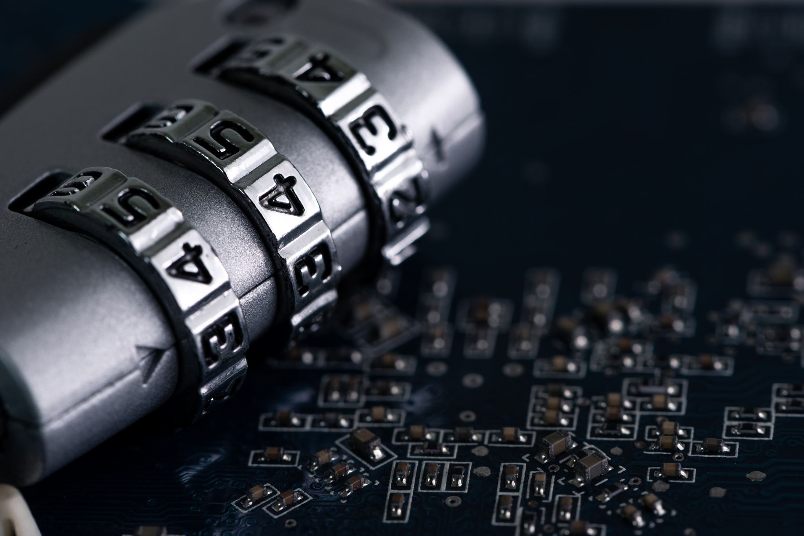
CPU is usually known as the “brain” of computer and also it is the heart of our system, responsible for every single activity and performing calculations executing single command. In every task like video editing playing games or simple browsing or using any application CPU is behind every action work on a computer takes. CPUs like intel co i 9 or AMD Ryzen series are pack of billion of tiny chips which enable them to handle very complex task with remarkable efficiency and in a QuickTime.
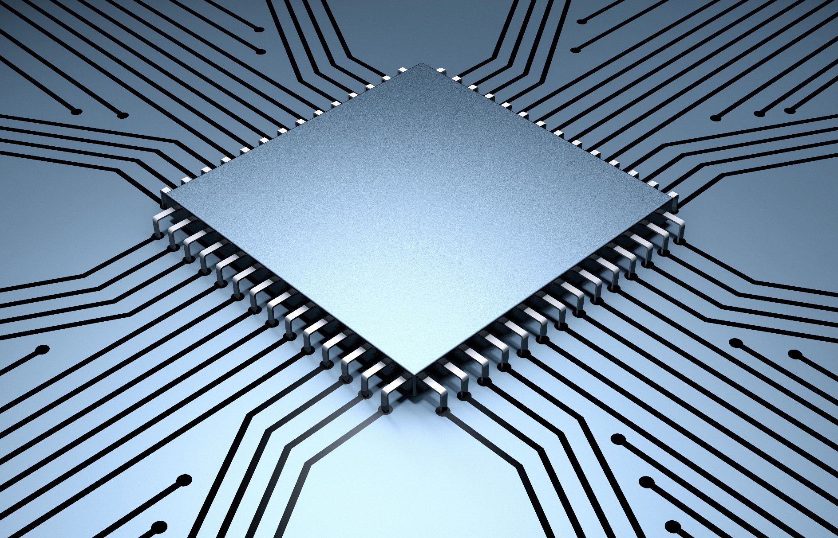
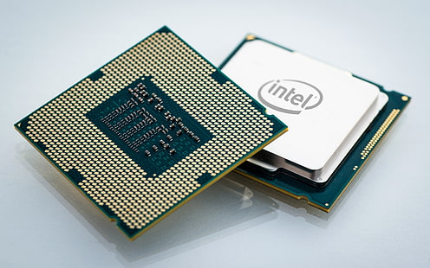
RAM(Random Access Memory)
Ram is also known as temporary memory as it holds the program and data, which are currently in the process or processing. All the data is removed all vanished as the computer is turned off or in case of power loss. Data stored in memory can be changed. The size and speed of ram effect all system performance. If in case ram storage is less your system might run less applications are the speed will be reduced, and the processing will become slow as the rent storage will large so we we can run more applications side by side which will not even affect the speed of our computer or laptop.
Motherboard
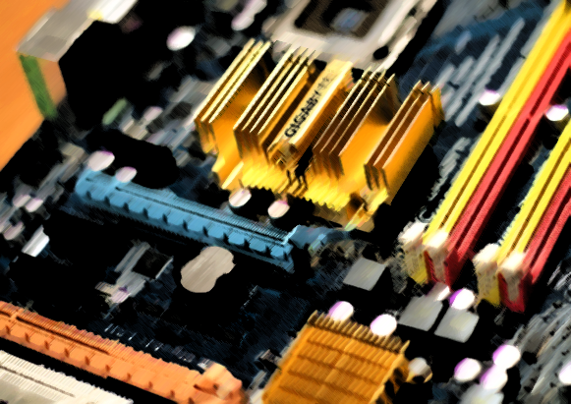
Motherboards provide the structure for all other components an make a connection between them, it is also known as “backbone of the computer”. While it also provides all the connection to the device an provide power supply moreover it connects other hardware devices like mouse printers and keyboards to computer. It controls how data is transferred motherboard consist of all other little parts which are essential for computer to run all the applications and web browsers motherboard also consists of ram CPU Ain other hardware drives which consist of memory SSD cards

Power supply
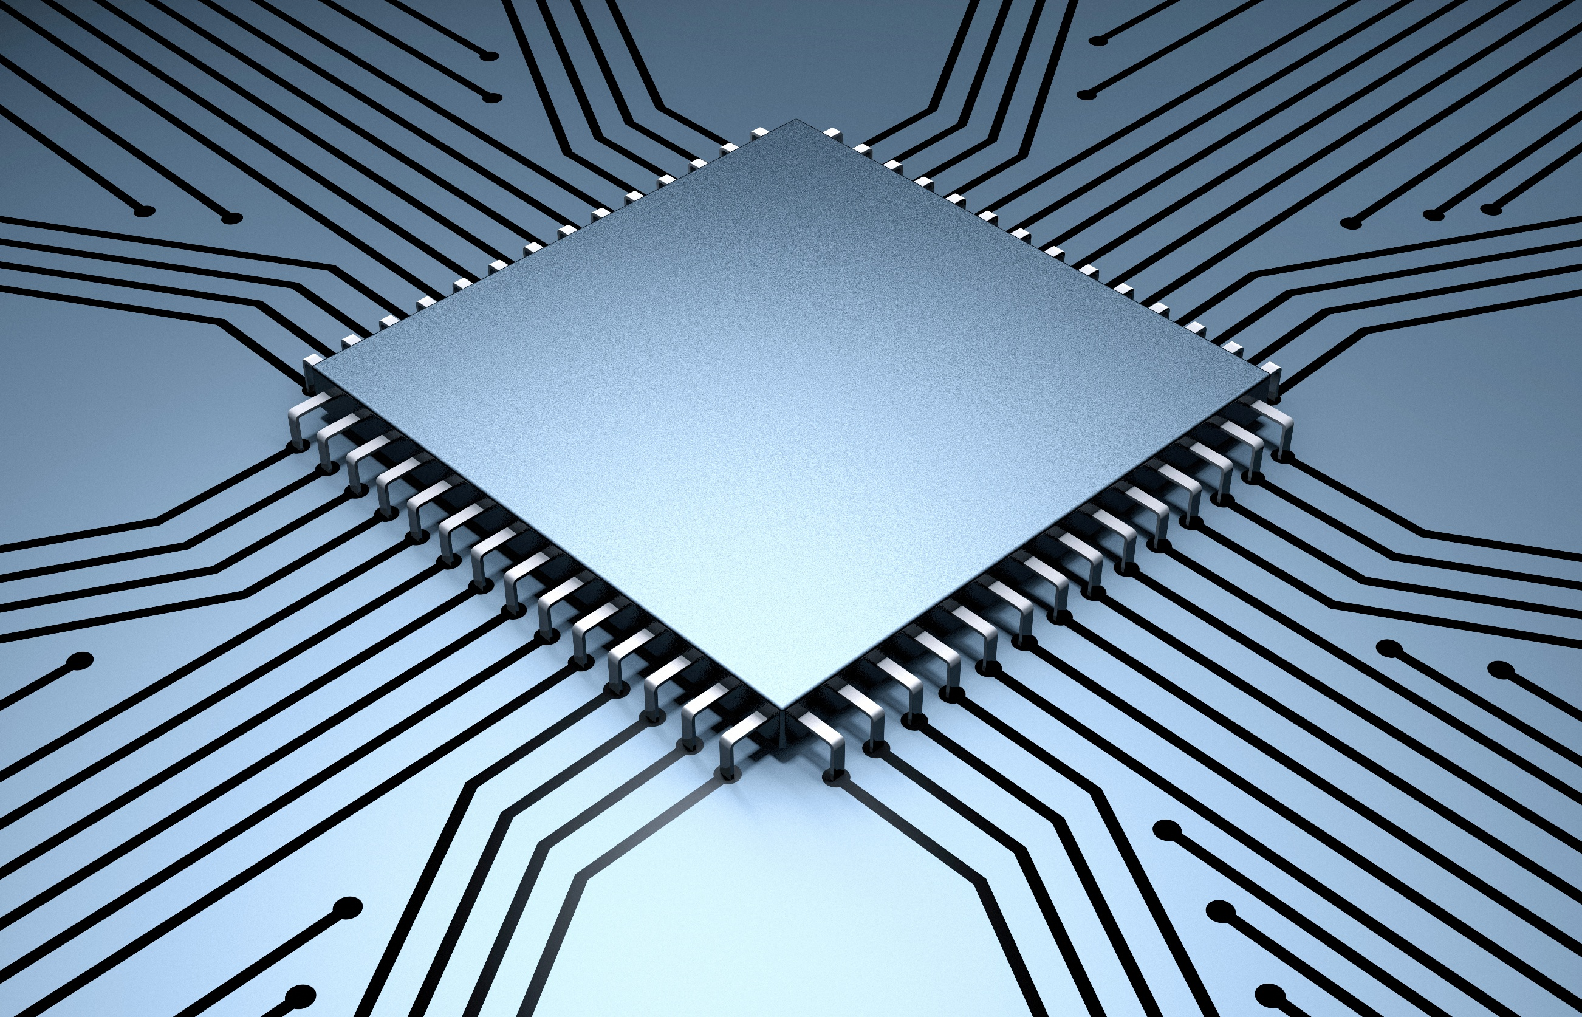
Power supply provides electricity to all computer components. Basically, it's a power cord connected from the back of PC into electric socket. As a computer needs a lot of power as compared two laptops, so power supply is the main component to run a computer, and it is connected to motherboard which further divides power supply to CPU and ram and other more components to run a computer.
Cooling fan
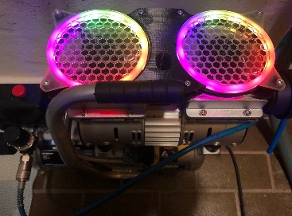
while running a big software or application computer CPU get heated up due to which its performance gets reduced, so a cooling system is most needed so come cooling fans are there two decrease overheating mining computers have more than one cooling fans to reduce the heat produced by running heavy gaming or streaming such as video edit. Basically, computer fans are please over CPU with a thermal paste which help to maintain proper temperature of CPU to give best performance to the users. Nowadays there are more water-cooling systems which help to reduce heat while running heavy applications and video editing
This Photo by Unknown Author is licensed under CC BY

Hard drive
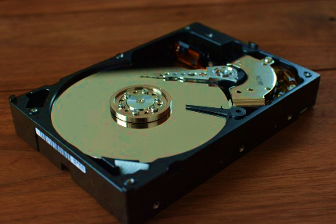
Hard drive usually stores the data N files program and other information on computer system they are magnetically coated disk all the hard disk picture, videos programs, applications are stored in hard drive As much hard drive will be big the more data we can store easily on computers or laptops and we can restore data in any order there are two types of hard disk HHD and SSD. Sometimes we need more stories so we can add some more accessory or hard drives in a personal device to increase the storage.
Net work devices
In some laptops or computers to access Internet connection we have to insert some Ethernet cards and Wi-Fi adapter connection so we can assess our local network or have Internet connection these chips are inserted on motherboard, but nowadays which computers or laptops are coming they're already inserted with these ethernet chips.
Output devices:
Output devices such as monitor printer speakers provide some visual printed an audible outputs like monitor usually displays are output or the programs which we are running an speakers usually provide some audios that computer is outputting to us modern monitors offers resolution up to 8K and support HDR resolution which is very like what if to the users moreover there are other output devices such as printer and projectors.

Input devices
Input devices are those devices from via computer gets any command from the user like keyboard , touch screen , mouse are examples of some input devices. Keyboard is used for typing some text or entering some commands, mouse is used to scroll some text or select some area same over touch screen uses touch any application to open basically input devices takes information and give commands to computer.

Troubleshooting
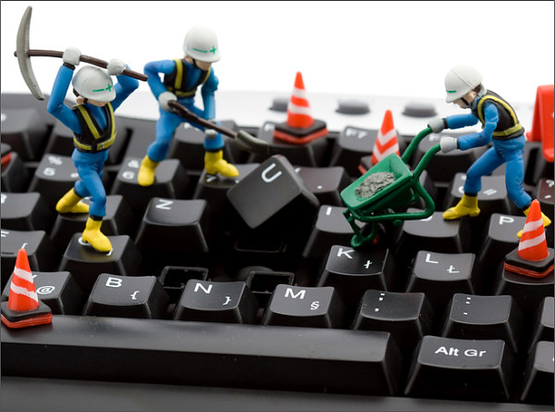
Troubleshooting is a systematic way to identify resolve hardware issues it involves a sequence step that help to diagnose a problem in efficient way. Each step is designed to narrow down the cause of troubleshoot an everyone should know about each component and how to troubleshoot the problem if any occur in the computer
This Photo by Unknown Author is licensed under CC BY
Troubleshooting steps:
- identify the problem gather information about where is the issue or which component is not working properly
- Look for the recent change that may have occur in our system or in a particular application
- carry on the solution with best analyzation and monitor the results ensure that solution is for the right problem
- ensure that problem is resolved, and the system operates correctly record the problem solution any relevant details for the future use.


Scenario 1: No Display on Monitor
Issue Identified: - If there is no display on your device first check the power supply and make sure it is connected to CPU, make sure RAM is properly placed to its right place, After this also is there any problem Explanation: there can lot of problems in a device because of which it can’t perform it’s task as per to assigned.I some cases cables are loss so montor can not work and power is not connected .
Troubleshooting Steps:
- Check Monitor Power Supply is on and having a working connection.
- Reset or reinsert the RAM to make sure that is it properly seated.
- If there is a beep sound then there is a hardware issue in motherboard due to which display is not working.

Scenario 2: Continuous Beeping Sound on Startup
Issue Identified: commonly in motherboard they are problems like failure to boot random shutdowns hardware not being recognized solution for that is to check the physical damage loss of connection are you may use post to identify issue being code can be providing specific error information.
Explanation: If the motherboard fails POST, it may indicate the power supply issue or deactivate motherboard. I n processor there can be many problems like overheating system freeze an failure to run any application this can be due to overheating or the friends or cooling system aren't in function.
Troubleshooting Steps:
- Improper power supply can be a reason for instability, power supply should be adjusted according to needs.
- Make sure ram and graphic card are properly seated and cleaned is any dust then clean it properly.
- Make sure your CPU is not overheating while running a heavy application.


Dick Storage Issue: router is slow down our daughter is getting lose or if we can't assess are old files there can be issue in our disk storage to reduce problem in our disk storage, we should clear unusual files which are not in use or increase some storage in our machines regular backup are essential to prevent data loss.
- -Even by clearing the storage computer processing maybe faster.
- Add SSD or HHD cards to device to increase storage so programs can run effectively.
- Delete unwanted file and applications to clear up space to have a better speed .

Scenario 3: Unresponsive Keyboard and Mouse
Issue Identified: There may issue in input devices because of which system could not response. There may be a fault in USB ports that prevent mouse or keyboard form working and loose cables can disrupt the input devices to work
- Explanation: There are serval reasons because which there can be problem in keyboard or mouse , the use ports can be damaged or wires might be broken, the computer may not support the devices .
Troubleshooting Steps:
- Make sure USB ports are in working condition by connecting the input devices somewhere else.
- In some cases, a restart can resolve the problem of mouse and keyboard.
- Check the input devices are not damaged or are in working condition.

- Use memory diagnostic tool test mam is in good condition or not.

Scenario 4:
Over Heating and shut down: over heating means when a CPU get heated up and get in worst condition due to which processor get slow and cause shutdowns, when running a big app or games mostly at that time computer gets heated due to high load on GPU and CPU

Issue Identified: over heating can be caused by many factors such as while running a heavy application or game but the ram does not support a such huge application.in some cases due to dirt collected in PC there is not ventilation which leads to high temperature in CPU.
- Clean vents and cooling fans with high pressure air to have a better flow of air.
- If there is overheating replace thermal paste which reduce temperature.
- Check cooling fan as, they are working properly or not, if there is a issue replace fans for upgrade cooling system.

Scenario 5:
Slow System Performance:
Issue Identified: while playing a game or running a application there may a sudden slow down or we may stuck at one phase or screen.
Explanation:
This can be due to over heating or over load on ram, as computer feel so heavy and become slow in speed and can not process the application as quick it can do .
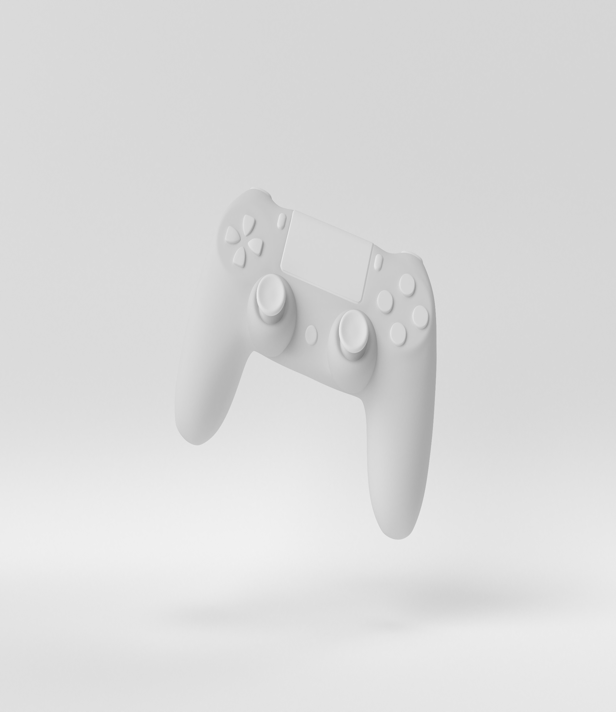

Troubleshooting Steps
- Check your computer hardware – as the vents are clean and their is no dust in CPU are ram due to which sometime there may be error in running programs properly.
- Close all programmes that are not in use and tabs too. So computer can get reduces it loads and response quick.
- Restart your computer likely u haven’t restart your computer in a day u might restart your computer, it might increase your device performance.

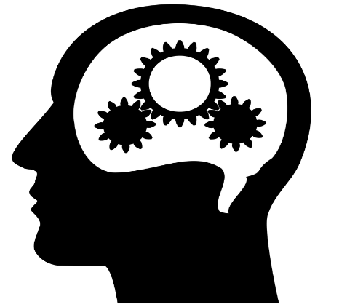
Systematic thinking is a powerful approach to solve problems as it resolves around a few key principals that guide understanding the complex issues, there are following steps: Identify the issue, find the problem that need to be solved. Next, examine the problem in depth, gather all information, and break down into small thoughts so understanding become easy and then find a appropriate solution for the problem. In this we can process all thought in a well manner to prevent confusion and miss understanding, In addition the thought process become fast and accurate. These are some steps to solve problem with systematic thinking.
- Identifying the problem
- Gather information and data
- Analyze the information
- Taking out appropriate solution
- Implement the solution
- Evaluate the result.

